OPARNO ARCH BRIDGE *( template only)*

|  |  |  |  |  |
| --- | --- | --- | --- | --- |
| *(current*  *passport-size photo)* | *(current passport-size photo)* | *(current*  *passport-size photo)* | *(current*  *passport-size photo)* | *(current*  *passport-size photo)* |
| Milan Kalný  Corresponding Author | Václav Kvasnička1 | Jan L. VítekCorresponding Author | Robert Brož | Alexandr Tvrz |

#### Abstract

The new Troja Bridge in Prague, which is now under construction, has a main span of 200.4 m long. The steel network arch with the bridge deck made of prestressed concrete represents an advanced bridge structure. The construction combines several technologies, including incremental launching and assembly of the arch from the bridge deck supported on temporary piers in the river.

##### **Keywords:** Concrete, Recycled waste, Environmental assessment, Optimization

# Introduction

The Oparno arch bridge is situated on the D8 motorway from Prague to Dresden in a scenic hilly landscape in the preserved natural area called “České Středohoří”. Due to its location, special requirements and limitations had to be met during construction of the bridge. The visualization is shown in **Fig. 1**. Each of two parallel, almost identical, bridges supports two lanes of the motorway. The length of the bridge is about 275 m and the span of arches is 135 m. After completion, the bridge will have the second longest span of the concrete arch in the Czech Republic. A beautiful countryside along the bridge was one of the reasons why an arch bridge was chosen for erection. The aim was to build a structure which is elegant, fits well into the landscape, is durable with low maintenance costs and complies with the requirements on sustainability.

# Bridge Design

The concept of the bridge was prepared already in 1998, when planning of the motorway started. Due to the delay caused by land acquisition and negotiations associated with a construction permit, the construction could not begin earlier than in 2008. During the ten years, the technology of concrete developed and it was possible to optimize an original design. In co-operation with the consultant and the contractor, higher strength classes of concrete were used for the arch as well as for the deck and piers. It resulted in substantial savings of volumes of concrete and made the structure lighter and even more durable. The proposed and then realized changes led to savings in cement consumption and thus contributed to the savings of energy and reduction of emissions of carbon dioxide.

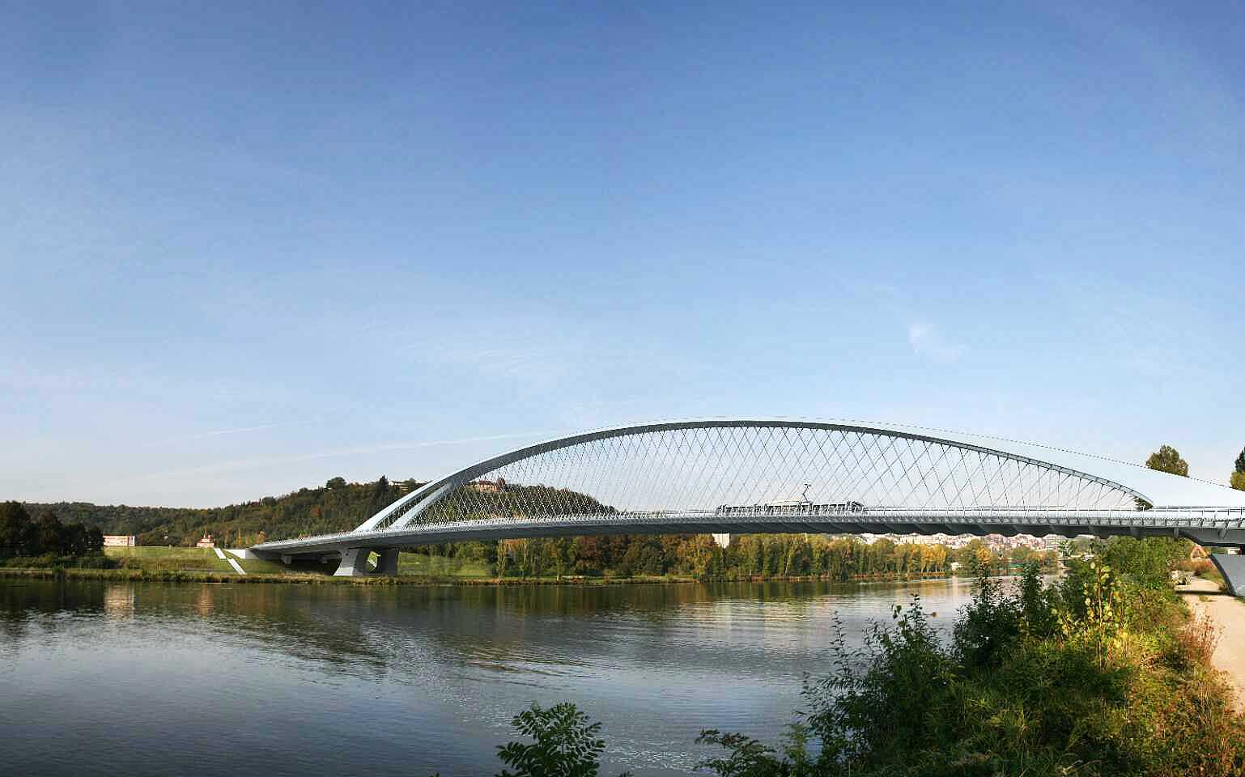

1. Visualization of the complete bridge [1]



1. Longitudinal section [2]

## Foundation

Both arch and pier foundations are designed in the form of spread footings located in steep valley slopes, where they rest on the weathered rock layers of gneiss or sandstone in the depth of 3-5 m under the ground level. Stepped arch foundations are loaded by high vertical and horizontal forces, therefore, the foundation area is about 12-14 m long and 30 m wide. The foundations of piers between the abutments and the arch footings are provided with prestressed ground anchors to stand up to the uplift due to temporary cable stays.Piers and abutments. Longitudinal section is shown in **Fig. 2**.

## Piers and abutments

Standard abutments with hung up wing walls have rounded edges and slope claddings from a local quarry. Both piers on the valley slopes and piers above the arch are designed as walls with dimensions 5.5×1.1 m (0.8 m above the arch), and the outside edges are chamfered, and opening under the superstructure is provided. Pot bearings are installed on the last side piers and on abutments, while all other piers are fixed to the superstructure with hinges. The height of piers varies from 10 to 31 m, piers above the arch are up to 17 m high.

## The arch and the deck

A reinforced arch made of concrete class C45/55 has a variable thickness of 1.3 to 2.4 m and a width of 7 m, and two ribs connected by the upper slab and inclined faces. The axis of the arch is straight, while the bridge alignment is slightly curved; the difference is up to ±0.35 m. Each longitudinally prestressed bridge deck has two beams 1.2 m deep and is 14.3 m wide.

# Measurement *(template only)*

The arch with the cross-section of an inverted U-shape is made of concrete class C45/55, which allowed for finding a good balance between the weight and load-carrying capacity. The reinforcing bars, 40 mm in diameter, were used in the lower parts of the arch.

 (1)

 (2)

A cantilever casting method of the arch required the development of special form travellers for segmental construction. The length of segments varied up to the length of 5.6 m. One half of the arch is composed of 14 segments, see **Tab. 1**.

1. Compressive reinforcement stress **s [MPa] at points B and C

|  |  |  |  |  |
| --- | --- | --- | --- | --- |
| ***D*M/**b** | ***f*ck = 20 MPa** | | ***f*ck = 55** **MPa** | |
| **s(B) | **s(C) | **s(B) | **s(C) |
| 4 | 46 | 76 | 91 | 148 |
| 7 | 97 | 191 |
| 10 | 119 | 234 |
| 15 | 156 | 306 |

The bridge deck is a continuous girder with spans in a range from 17.5 to 24 m. The cross-section has a double T shape. After evaluation of several alternatives of construction, it was decided to use an overhang movable scaffolding system (MSS), with two main top steel beams located above the bridge deck. The main steel beams are supported on the definitive piers using a special steel supporting element. The longitudinal main steel beams are at the end provided with long cantilevers allowing for moving the MSS into the next casting position. The formwork is suspended on the transverse frames supported on the main longitudinal beams, see **Fig. 5**.

|  |  |
| --- | --- |
|  |  |
| 1. Upper strain gauge | 1. Temperature sensor |

# Bridge Design

The construction was significantly influenced by local conditions. In the preserved natural area, the site was limited to a very narrow space, covering practically only the width of the bridge. No activities and access were allowed under the arch. The access to arch footings was very limited. The construction had to be divided into two almost independent sites located at individual ends of the bridge. The requirements to build the bridge symmetrically required two sets of equipment for both the arch construction and for the bridge deck construction, which increased the cost of the bridge.

## Piers and abutments

**Pier**

The construction started with the arch foundations and with the highest piers located above the arch footings. They were used as a support for temporary stays supporting the arch during its construction. The piers were cast in self-climbing formwork designed by PERI, which made it possible to build the piers rather quickly in segments 3.6 m high.

**Abutments**

The formwork of abutments and of other structures was made of timber, in order to provide the convenient architectural appearance of the concrete surface. After demoulding, the concrete was covered by a PE membrane, so that fast drying was avoided and possible cracking eliminated.

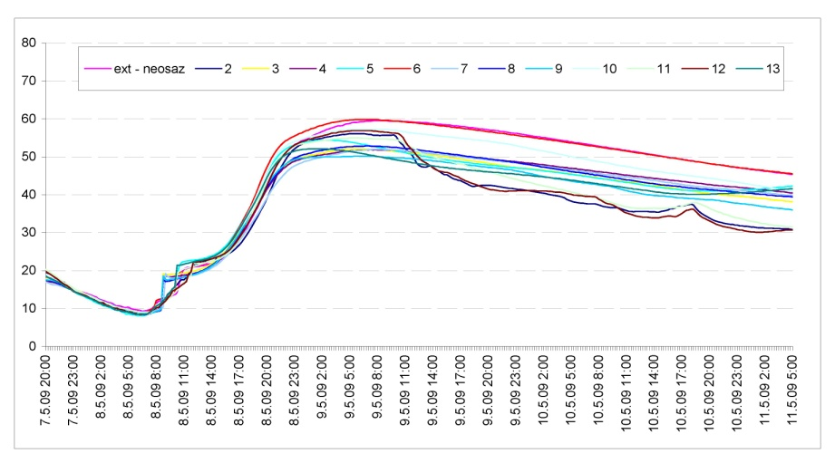

1. Arch temperature measurement during the cooling

## Arch of the bridge

The self-moving form traveller for the arch construction was developed by PERI. The schematic view is plotted in **Fig. 3**. The main parts of the traveller are the longitudinal beams beside the concrete arch, which are connected by a pair of cross-beams supported on the already completed arch segment. Several platforms are used for reinforcement assembly, for access to the formwork and for curing of concrete after moving of the traveller to the next casting position.

## Sequence of construction

After the completion of foundations and piers outside the bridge arch, the bridge deck was built from both ends of the bridge. Simultaneously, the arch was cast from the footings. The three spans which are supported on piers outside the arch form a tie and allow for erection of the temporary pylon, which was used for temporary suspension of the erected arch. After closing the arch, a part of the stays could be removed and the MSS could be used for casting of the bridge deck above the arch. The casting procedure has to be symmetrical so that the excessive stresses in the arch would be avoided. After completion of individual activities, the equipment was moved to the second bridge. The temperature was measured by a temperature sensor, see **Fig. 4**.

# Conclusions

The bridge over the Oparno valley is a modern bridge which represents an aesthetic and durable structure with minimum details requiring maintenance. The construction process was developed in such a way, which minimizes the interference of the building activities with an environment in the preserved natural area. Special attention was paid to the durability of the bridge and the reduction of the amount of materials used. Application of concrete of a higher strength led to the reduction of the self-weight of the bridge and additional savings of steel reinforcement. The design and execution teams believe that the arch bridge will be a landmark, satisfying the conditions of economy, aesthetics and durability in the long-term, and that it will successfully serve the public for the next hundred years.

# Acknowledgement

Some results of the research carried out under the support of the Ministry of education, youth and sports of the Czech Republic (Research centre CIDEAS – Project No. 1M0579) were used during the construction. This support is gratefully acknowledged.

###### References

1. Kalný, M., Němec. P., & Kvasnička, V. (2008). *Realizační dokumentace stavby D8 – 0805, Lovosice – Řehlovice, část C SO205 most Oparno* (in Czech)*.*
2. Kalný, M., Němec. P., Kvasnička, V., & Brož, R. (2008). *Projekt a zakládání obloukového mostu Oparno* (in Czech), In *Proceedings of the Czech Cocrete Day 2008*, Hradec Králové, Czech Concrete Society & CBS Servis.

|  |  |
| --- | --- |
| Ing. Milan Kalný   Pontex, spol. s r. o. Bezová 1658, 147 14 Praha 4  Czech Republic   +420 244 462 231   +420 244 461 038  ☺ [kalny@pontex.cz](mailto:kalny@liapor.cz)  **URL** [www.pontex.cz](http://www.pontex.cz/) | Ing. Václav Kvasnička   Pontex, spol. s r. o. Bezová 1658, 147 14 Praha 4  Czech Republic   +420 244 462 231   +420 244 461 038  ☺ [kvasnicka@pontex.cz](mailto:kvasnicka@pontex.cz)  **URL** [www.pontex.cz](http://www.pontex.cz/) |
| Prof. Ing. Jan L. Vítek, CSc.   Metrostav a.s. Koželužská 2246, 180 00 Praha 8  Czech Republic   +420 266 709 317   +420 266 709 193  ☺ [vitek@metrostav.cz](mailto:vitek@metrostav.cz)  **URL** [www.metrostav.cz](http://www.metrostav.cz) | Ing. Robert Brož, Ph.D.   Metrostav a.s., Divize 5  Na Zatlance 13, 150 00 Praha 5  Czech Republic   +420 606 791 204   +420 266 786 638  ☺ [robert](mailto:robert).broz@metrostav.cz  URL [www.metrostav.cz](http://www.metrostav.cz) |
| Bc. Alexandr Tvrz   Metrostav a.s., Divize 5 Na Zatlance 13, 150 00 Praha 5  Czech Republic   +420 602 345 646   +420 266 786 638  ☺ [tvrz@metrostav.cz](mailto:tvrz@metrostav.cz)  **URL** [www.metrostav.cz](http://www.metrostav.cz) |  |